PE Funding

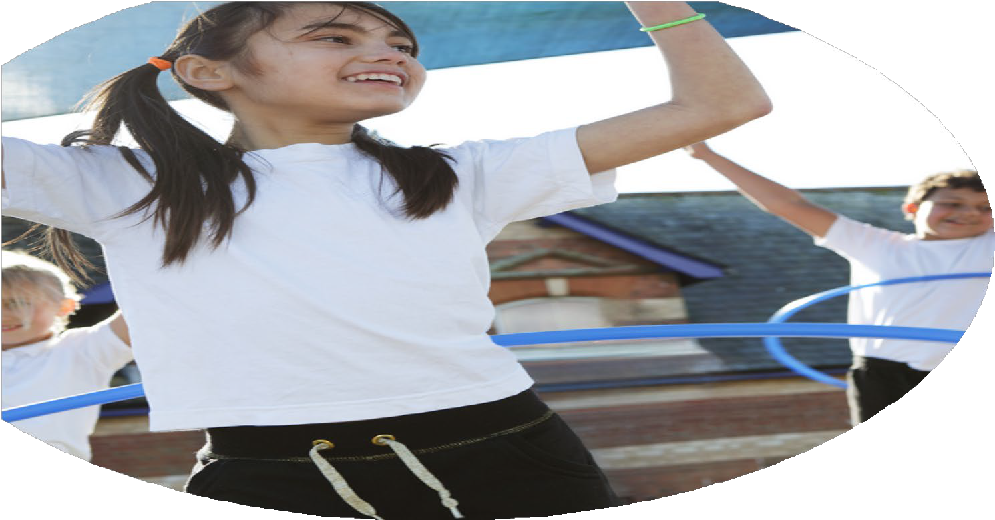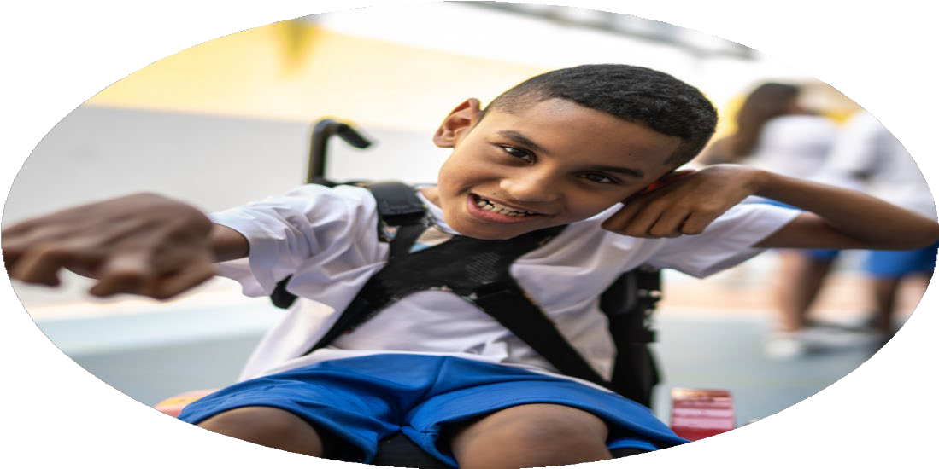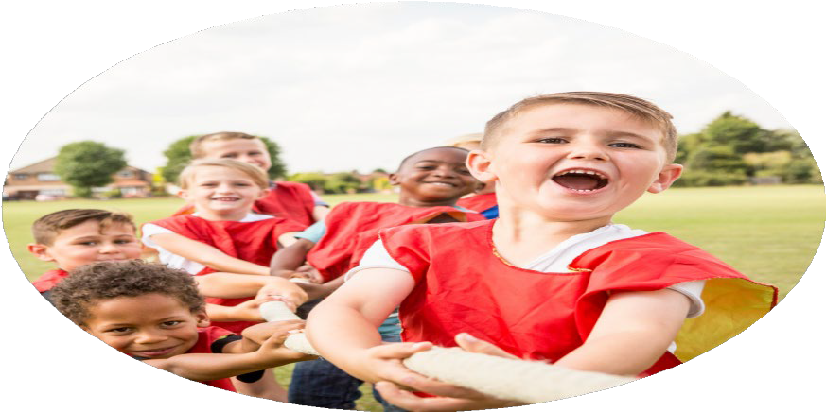

Evaluation Form

**Commissioned by**

**Created by**

Images courtesy of Youth Sport Trust

**PE Funding Evaluation Form**

 It is intended that this template should be used as preparation for the completion of the statutory digital reporting tool being introduced this academic year. You can upload data (including swimming) from this template onto this platform once it becomes accessible.

 Before you decide how you are going to use the funding for this academic year you should reflect and evaluate the impact of your use of the funding in 2023/24.

 All spending of the funding must conform with the terms outlined in the Conditions of Grant document.  The template is a working document that you can amend/update during the year.

 Based on your evaluation of last year’s funding you should decide what you intend to do this academic year, how you will do it, and what impact you expect it to have.

It is important that the funding is used effectively and based on your school’s needs.

 You must use the funding to make additional and sustainable improvements to the PE and sport in your school.  You must develop and add to the PESSPA activities that your school already offers.

*Summative digital reporting from June 2025 will continue to include swimming and water safety information therefore funding can be used to provide top-up lessons where necessary to ensure pupils meet national curriculum swimming requirements.*

**We recommend that you start by reflecting on the impact of current provision and reviewing your previous spend**

|  |  |  |  |
| --- | --- | --- | --- |
| What went well? | How do you know? | What didn’t go well? | How do you know? |
| Children were able to improve and develop their skills in various sports, including sessions that were organized by external coaches.  The Active Cumbria Street Tag challenge was popular and engaged whole families. | More individuals joined external clubs for cricket, rugby and football, karate and judo.  We won the small school Street Tag trophy on three separate occasions as we had the largest number of points for the families whoa had participated. | Number of children who achieved end of Year 6 standard for swimming. | Many of the children could not access swimming lessons apart from at school, due to Covid restrictions. Consequently, there were a large number of children who were non swimmers when they started KS2. We could not provide extra sessions at the swimming pool due to the large number of schools using the facility. |

|  |  |
| --- | --- |
| What are your plans for 2024/25? | How are you going to action and achieve these plans? |
| Intent | Implementation |
| This year we have £16,810 of Sports premium funding.   * Ensure staff are confident to deliver gymnastics throughout key stage 1 and 2. * Improve the quality of P.E. particularly the games strand in KS2 * Purchase new equipment for P.E and the playground | * Individual staff to attend training for Gymnnastics in Autumn term. * Book coaches for rugby, football and cricket to lead some P.E. sessions throughout the school year. This will allow teaching staff to observe and work alongside the coaches and develop their own skills and expertise. * This will improve playtimes and make them more active.   P.E equipment that is worn and needs replaced, will ensure safety and adequate use of resources for P.E. lessons. |

|  |  |
| --- | --- |
| What impact/intended impact/sustainability are you  expecting? | How will you know? What **evidence** do you have or  expect to have? |
| * The staff will be much more confident when delivering P.E. lessons in games for KS2 * More children will be able to access gymnastics in school and participate in competitions * Children from Year 1to Year 6 will have the opportunity to be involved in inter school competitions with HP Activities and UVHS * The number of Year 6 children who achieve the end of year target for swimming will increase. * The number of children with SEND who participate in P.E and sports will increase. * The school will participate in the Active Travel scheme and encourage children to walk, cycle to school. * Year 3 and 4 will take part in a residential trip got outdoor adventurous activities, including climbing, ghyll scrambling, canoeing, raft building and orienteering. | * Overall assessment data for KS2 P.E will improve. * Year 1 and 2 were offered a gymnastics club after school led by the class teacher. * Year 3 and 4 were able to train for Key Steps gymnastics competitions in school and at after school sessions. * KS1 children attended a multi skills session with UVHS which allowed them to develop their skills and confidence. * Year 2 also attended a football development session with HP Activities. This was enhanced by their after school clubs for multiskills. * Year 3 and 4 girls and boys attended football tournaments run by UVHS and HP Activities. * Year 5 and 6 attended inter school tournaments in netball and football. * HP Activities ran a series of P.E. sessions specifically for children with SEND in school. The children were engaged and enjoyed the sessions as they had the time and space to try out various activities without a competitive element. * Around 80% of children travel to school on foot or by cycling / scooting for part of the time, most weeks. This means that there is a reduction in car journeys and children are staying active. * All children will be able to participate in activities that they may not have experienced before. This will improve their confidence, teamwork and resilience. |

|  |  |
| --- | --- |
| What **impact/sustainability** have you seen? | What **evidence** do you have? |
| * KS1 children are much more experienced and confident in performing gymnastics correctly. * School staff led after school tennis sessions for Year 5 and 6 * The number of girls who have accessed football has increased this academic year. * The number of Year 6 children who were able to reach the end of year target for swimming, increased. * Playtimes have become much more active for all children. The purchase of new equipment has provided more opportunities for individuals to try different sports including dodgeball, rugby, tennis * More children travel to school on foot or by cycling using their scooter. * More children participated in sports at after school clubs. | * KS1 children came second in the Key Steps Gymnastics competition in March 2025. * KS2 children won the inter school Mini Tennis Tournament at UVHS in March 2025 including children with SEND. * We have been able to provide girls teams for Year 3,4 5 and 6 in inter school tournaments. * More girls are also accessing football outside of school and attending local football training. * 81% of children reached the end of Year 6 target. * The number of incidents at playtimes has reduced as children are more engaged in the activities and there is more equipment to use. * Across the year, 78% of children have regularly walked , cycled or scooted to school for at least part of the week. * 80% of Reception   75% of Year 1  90% of Year 2  67% of Year 3  87% of Year 4  64% of Year 5  90% of Year 6 took part in at least one after school club for sport during the 2024 – 2025 academic year.  This included multiskills, football, rugby, cricket and tennis. |